

South Midlands Postal Branch AGM
Dear CWU Member,
You are invited to the South Midlands Postal Branch annual general meeting - 2026
The meeting will take place on Monday the 30th March 2026 due to commence at 12 noon.
Rugby Railway Club, Hillmorton Road, Rugby, CV22 5AL
Please come along to make some very important branch decisions, get the latest updates, meet branch officials, branch representatives and other CWU members.
(Refreshments will be served)
Guest Speakers: Dave Ward – GS, Lee Wenban – PE/NEC


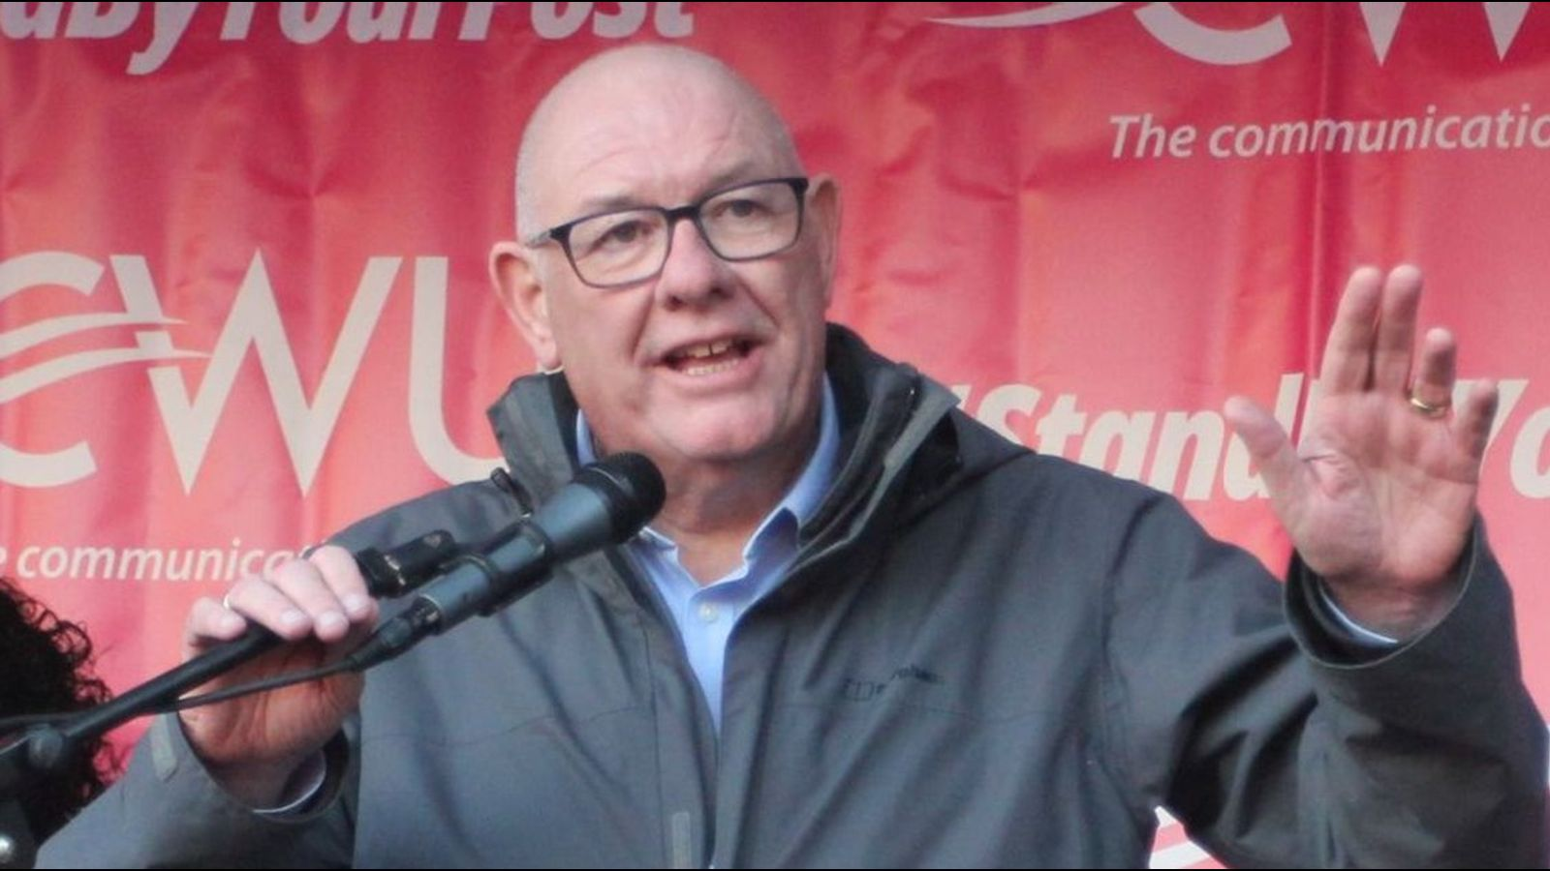

Facebook: CWU South Midlands Postal Branch X: @SouthMidsPostal www.cwusouthmidspostal.org #TheCWU

